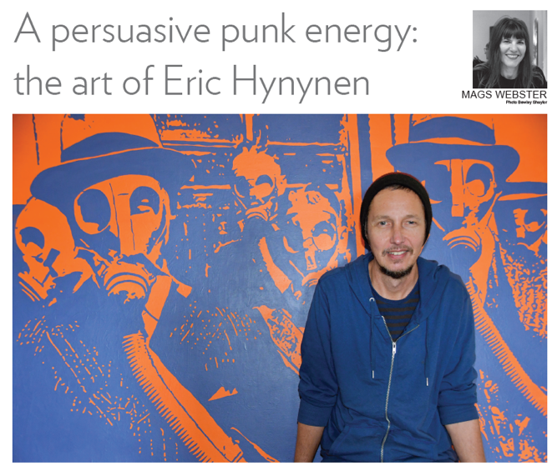
♦ Eric Hynynen in his Parkwood studio with his work Nothing
to see here, 120 x 170cm, acrylic on canvas. Photo Lyn
DiCiero.

Since 1974, Perth’s Finnish community has gathered at the Immanuel Finnish Lutheran Church, in a quiet corner of Parkwood. And for the past few years, this modest building south of the Canning River is where
artist Eric Hynynen (pronounced hoo-noo-nen) has been making his award-winning art.

Hynynen was born to Finnish parents in Sydney in the early 1970s, and soon after the family relocated to Perth. Hynynen did not engage in art at school; in fact, he trained in environmental health at Curtin University, beginning his working life as a laboratory technician. But in the 1990s, a four-year stint in Helsinki changed everything.

In order to maintain his Finnish citizenship, Hynynen needed to undertake mandatory National Service. He also got to know his second cousin, Jouko Alapartanen, an acclaimed artist. “We spent quite a bit of time together,” recalls Hynynen. “Jouko was painting and there was not much else to do so I just started to paint as well. I didn’t have any training at all at that stage so Jouko got me doing little watercolours and then I just moved on to different paints and techniques. Art totally felt comfortable.” And so when Hynynen returned to Perth in the late 1990s, he applied to and was accepted by Edith Cowan University to study art.

After studies, however, Hynynen “ended up just working in a laboratory, buying a house, paying off a mortgage. But it wasn’t for me. And so when I had the chance, I sold everything, took off again to travel.” He eventually landed back in Finland, where he was accepted for the Master of Fine Arts at Helsinki’s Academy of Fine Arts, a degree he completed in 2009.

This time, upon his return to Perth, Hynynen was committed to making art. His is a practice spanning
wide-ranging concerns and mercurial styles. As he explains: “My artwork is concept-driven, so whatever the best means are to get the message or the idea across is what I’ll do, whether it’s video, sculpture, painting. I’m not stuck on any one technique.”

The work of this quietly-spoken, contemplative individual not only explores the interstices of his dual heritage, but also interrogates and exposes the frictions between nature and the constructed bureaucratic and economic ‘systems’ controlling human society.

“A lot of my work is to do with nature, and also to do with ‘the system’ and how it puts people in a box,” says Hynynen. “Nobody likes an office, and these systems we’ve made. I don’t fit into these systems very well, and I don’t think people in general fit. When money decides what happens, problems come up worldwide. And, nature is everywhere. I think going to nature is the answer, really, but we need to combine the two.”

Nature of the Beast, Hynynen’s forthcoming solo exhibition at Stala Contemporary, does precisely that. It presents a comprehensive yet nuanced survey of the artist’s aesthetic and ideology, placing vibrant two-toned imagery of nature next to socio-political commentary, along with video works and installations.

One particularly striking acrylic on canvas is called Nothing to See Here, a film noir-esque rendition of people in trilby hats and gasmasks. It’s an apposite image for these COVID-stricken times; as Hynynen observes: “it’s like this is supposed to be ‘normal,’ we’re just doing our jobs, we’re supposed to accept restrictions and government overreach. I think it’s really important to keep going out and not give in to fear.”

In common with many of his artworks, Nothing to See Here is based on a source photograph, which the artist has scaled up and hand-painted in contrasting hues. The use of two colours, Hynynen explains, “is to do with Eastern philosophy’s unity of opposites, so with light and dark one doesn’t exist without the other. It makes the colour do the work.”

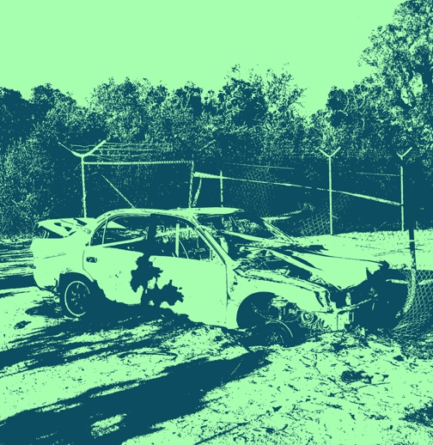
♦ Bad Parking, 76 x 76cm, acrylic on canvas by Eric Hynynen.

Another artwork is called Bad Parking - a car-wreck spotted “in the wrong place” during a bushwalk. Works like these are juxtaposed with paintings like Parklife, inspired by bushland close to Hynynen’s home, and The Way, which shares a Dwellingup scene: compelling imagery of trees and nature, which when viewed close up disintegrate into a meditative abstraction.

Since the mid-2000s there has hardly been a year when Hynynen’s work has not appeared in a group or solo show. What are his aspirations for Nature of the Beast?

Hynynen hopes to present “a generous exhibition that’s going to engage people on many levels. I think the artworld is lacking a bit of punk energy. Art should not be conservative, it should push boundaries and ask some questions, not just be safe and pretty. So I try and do a bit of both, balance things out. I think it’s important to say something and try and encourage something different.”

